**3. Exploratory Data Analysis**

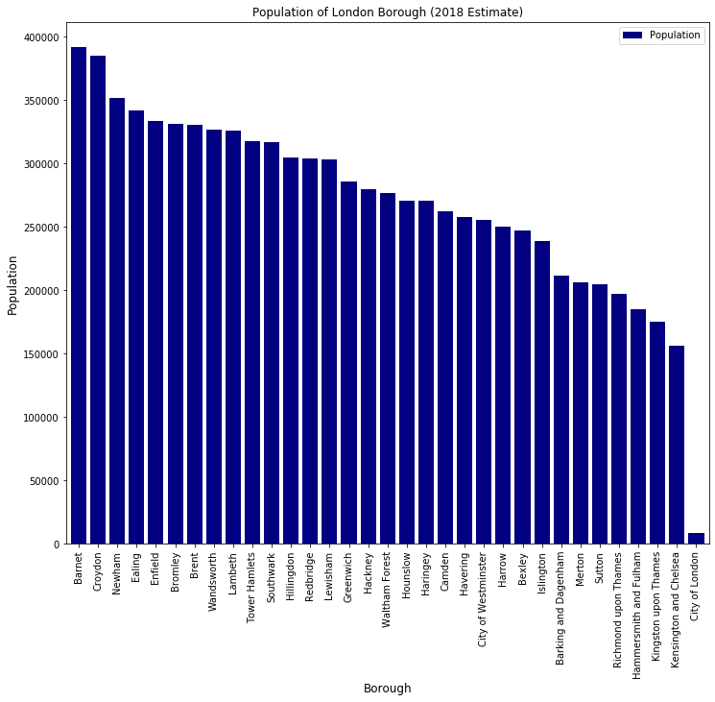

The ‘City of London’ Borough is London’s historical financial district and has an extremely small population. It was therefore decided to exclude it from subsequent analysis. Turning to crime statistics, I initially examined for outliers.

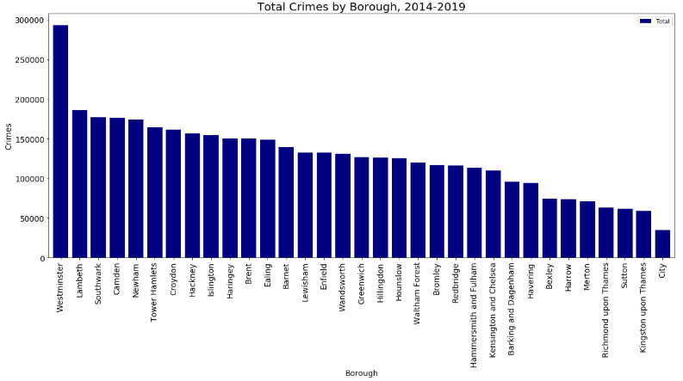

Figure 1: Total number of crimes by Borough (2014-2019)

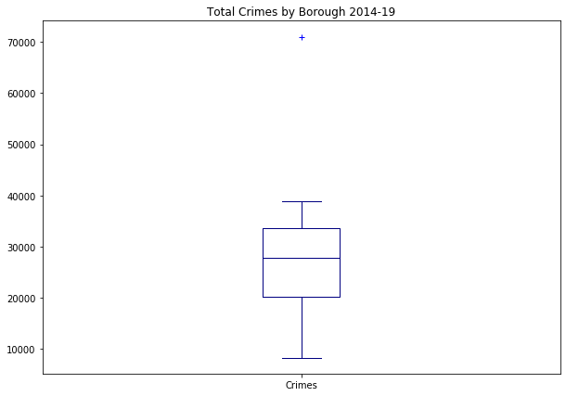

Figure 2: Boxplot to identify outliers.

Inspecting the data revealed that Westminster is an outlier.